Mining: Nonce and Cryptographic puzzle

Nonce is 32 bit no ranging from

0 to 4 billion..

Mining is a process to add blocks in a blockchain……….

It is done by miners………..

It is all about guessing a nonce having time stamp as a constraint….

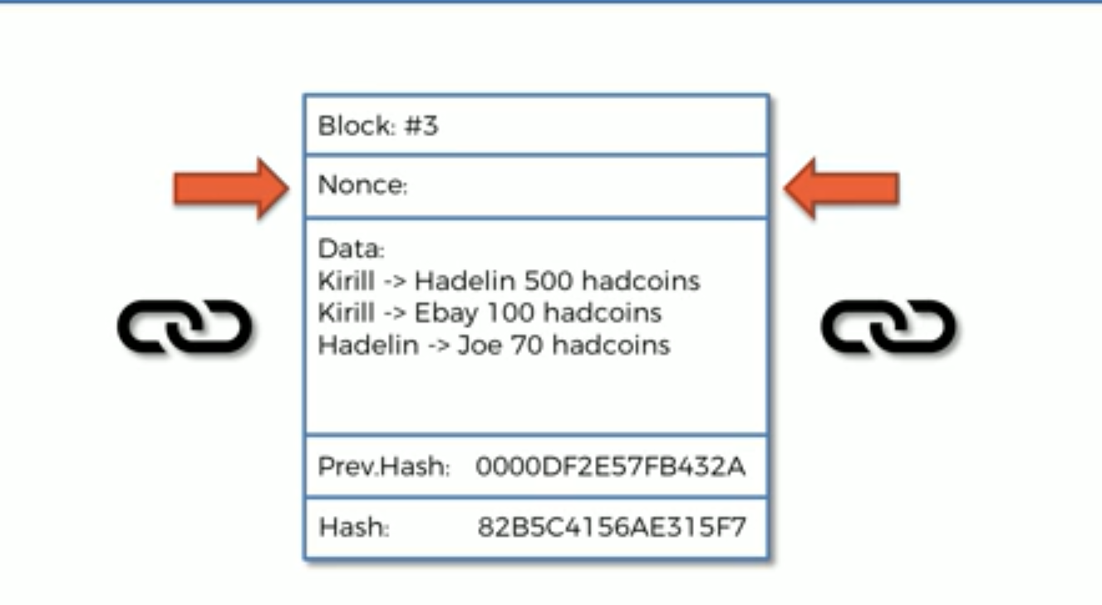

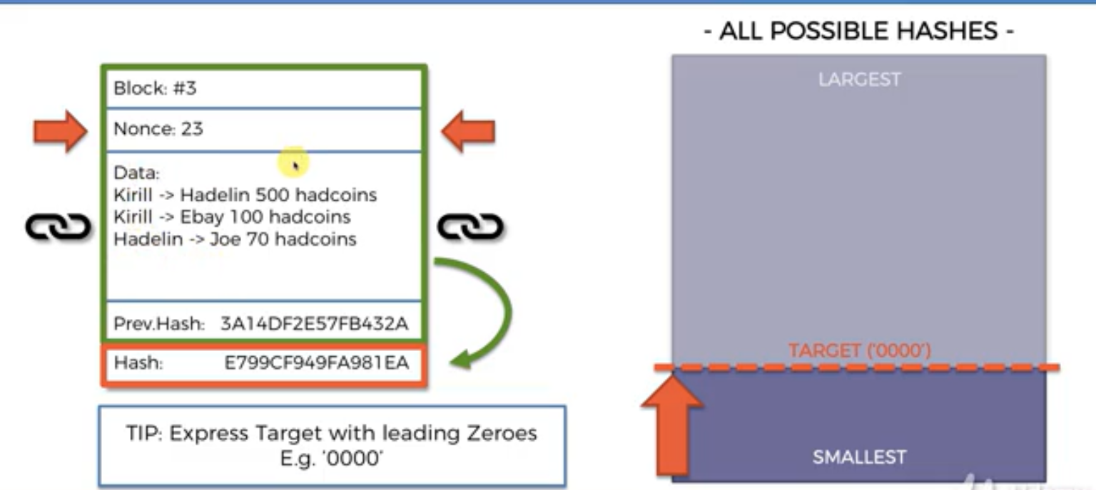

It requires lot of computational power

Leading zero is more than probability of guessing correct nonce will be very very very low……….

Guessing correct nonce means correct hash………….

Consider target has 18 leading zeros..

Total hash no’s are :16^64 ~ to 10^77

Valid hash are:10^64-18 i.e 10^56

Prob= 10^56/10^77 =10^-21

Very very low…………….

Mining is very difficuilt………..

China has 81% of mining stations…..

India has 1% mining stations…

Reason:electricity………….